POWER BI POWERED GLOBAL TERRORISM DATASET ANALYSIS

“NANJIL CATHOLIC COLLEGE OF ARTS AND SCIENCE,KALIYAKKAVILAI.

| **NM ID** | **NAME** |
| --- | --- |
| E64D6CB82C1F2589FC74036340155CF4 | MANU K S |

| **TRAINER NAME** | R UMA MAHESWARI |
| --- | --- |
| **MASTER NAME** | R UMA MAHESWARI |

**INDEX**

| **SI.NO** | **TABLE OF CONTENTS** | **PAGE NO.** |
| --- | --- | --- |
| 1 | CHAPTER 1:INTRODUCTION |  |
| 2 | CHAPTER 2: TERRORIST ATTACK BY REGION |  |
| 3 | CHAPTER 3: TERRORISM IN INDIA |  |
| 4 | DASHBOARD |  |
| 5 | CONCLUSION |  |
| 6 | FUTURE SCOPE |  |

**CHAPTER 1**

**INTRODUCTION:**

Although the term is not subject to a universally agreed definition, terrorism can be broadly understood as a method of coercion that utilizes or threatens to utilize violence in order to spread fear and thereby attain political or ideological goals. Contemporary terrorist violence is thus distinguished in law from “ordinary” violence by the classic terrorist “triangle”: A attacks B, to convince or coerce C to change its position regarding some action or policy desired by A. The attack spreads fear as the violence is directed, unexpectedly, against innocent victims, which in turn puts pressure on third parties such as governments to change their policy or position. Contemporary terrorists utilize many forms of violence, and indiscriminately target civilians, military facilities and State officials among others. The challenges of countering terrorism are not new, and indeed have a long history. The term “terrorism” was initially coined to describe the Reign of Terror, the period of the French Revolution from 5 September 1793 to 27 July 1794, during which the Revolutionary Government directed violence and harsh measures against citizens suspected of being enemies of the Revolution. In turn, popular resistance to Napoleon’s invasion of the Spanish Peninsula led to a new form of fighter—the “guerrilla”, which derives from the Spanish word guerra, meaning “little war” (Friedlander, 1976, p. 52). As a weapon of politics and warfare, however, the use of terrorism by groups can be traced back to ancient times, and as noted by Falk, “in various forms, terrorism is as old as government and armed struggle, and as pervasive” (Falk, 1990, pp. 39, 41). The focus of this module, and of the University Module Series as a whole, is on terrorist violence and the threats carried out by non-State groups and the response of the international community, especially States, regional organizations and the United Nations system.

**CHAPTER 2**

**TERRORIST ATTACKS BY REGION:**

From 2007 to 2022, the middle East and north Africa (MENA) suffered from the highest number of terrorist attacks, reaching over 23,000 incidents as of 2022.

23,000 incidents are in 2022 the region with the second highest number of attacks south Asia Recorded nearly 18,000 attacks during the same period. Terrorism is the threat or use of violence to intimidate or coerce in the pursuit of political or ideological goals. It is usually understood to be done by non-state actors — individuals or organizations not part of the government.

Terrorism can take many forms, including bombings, armed assaults, hijackings, or hostage-taking. Its targets can also vary and can be aimed at civilians, state actors, or public infrastructure.

Globally, terrorist attacks and deaths are rare. But this varies a lot worldwide: in some countries, they are common and on the rise, while in others, there are few attacks or none.

Terrorism is also a big concern for people across the world. Attacks are rare, but often shocking, as they are meant to scare and subdue.

**TALIBAN**

The Taliban conducted extra judicial executions, arbitaray arrests, torture and unlawful detention of perceived opponents with impunity. Creating an atmosphere of fear.Taliban fighters took their first provincial capital on 6 August - and by 15 August, they were at the gates of Kabul.Their lightning advance prompted tens of thousands of people to flee their homes, many arriving in the Afghan capital, others heading for neighbouring countries.And there was chaos in Kabul, as President Ashraf Ghani fled the country and thousands of his countrymen and women tried to do likewise.

**NUCLEAR WEAPON**

The atomic bomb dropped on Hiroshima, Japan, killed 70,000 people initially, with tens of thousands more succumbing to radiation sickness over subsequent months and years. A **nuclear** weapon[[a]](https://en.wikipedia.org/wiki/Nuclear_weapon#cite_note-1) is an [explosive device](https://en.wikipedia.org/wiki/Explosive_device) that derives its destructive force from [nuclear reactions](https://en.wikipedia.org/wiki/Nuclear_reaction), either [fission](https://en.wikipedia.org/wiki/Nuclear_fission) (fission bomb) or a combination of fission and [fusion](https://en.wikipedia.org/wiki/Nuclear_fusion) reactions producing a nuclear explosion. Both bomb types release large quantities of energy from relatively small amounts of matter.

**CHAPTER 3**

**TERRORISM IN INDIA**

India ranks 14th in the GTI 2024 report, slipping down by one spot from last year. It is among the top ten countries with the largest decreases in deaths from terrorism. India has long suffered violence from extremist attacks based on separatist and secessionist movements, as well as ideological disagreements. In particular, the territorial dispute over India-controlled Kashmir is believed to have fueled large-scale terrorist attacks, such as the bombings of a Mumbai commuter railway in July 2006 as well as a deadly explosion on an India-Pakistan train line in February 2007. Kashmir-related terrorist violence draws international concerns about its possible link in a chain of transnational Islamist militarism. The terrorist assault on Mumbai’s hotel district on November 26, claimed by a previously unknown group calling itself the Deccan Mujahadeen, appears to confirm a disturbing new turn of events domestically. Recently, a group calling itself the [Indian mujahadeen](http://www.time.com/time/world/article/0,8599,1826950,00.html) joined the roster of terror forces, claiming responsibility for a series of blasts in November 2007 in the state of Uttar Pradesh and 2008 attacks in the Indian cities of New Delhi, Jaipur and Ahmedabad. Their relationship with the new Deccan Mujahadeen group remains unclear. India also faces another extremist threat: A Maoist insurgency by violent revolutionaries called "Naxalites" has emerged across a broad swathe of central India-nicknamed the "red corridor"-to claim a growing number of lives.

**RELIGIOUS TERRORISM**

Terrorism in the name of religion has become the predominant model for political violence in the modern world. This is not to suggest that it is the only model because nationalism and ideology remain as potent catalysts for extremist behavior. However, religious extremism has become a central issue for the global community. In the modern era, religious terrorism has increased in its frequency, scale of violence, and global reach. At the same time, a relative decline has occurred in secular terrorism. The old ideologies of class conflict, anticolonial liberation, and secular nationalism have been challenged by a new and vigorous infusion of sectarian ideologies. Grassroots extremist support for religious violence has been most widespread among populations living in repressive societies that do not permit demands for reform or other expressions of dissent.

**DASHBOARD**

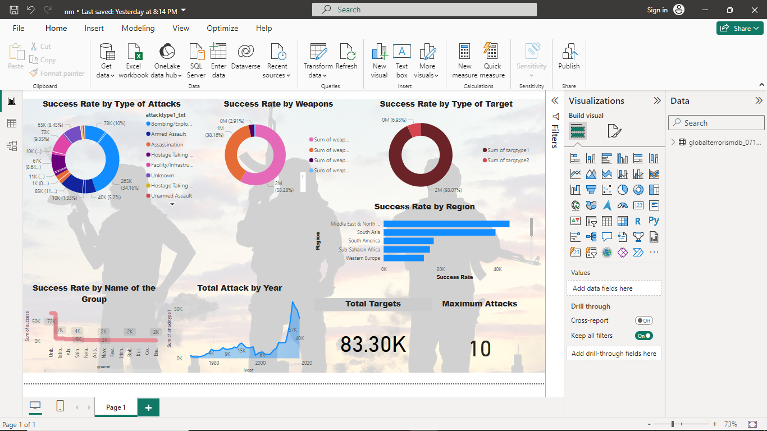

**CONCLUSION**

[Terrorism is a significant threat to global security that requires cooperation among international states and intelligence agencies to increase efficiency](https://www.bing.com/ck/a?!&&p=99a0c034ffced970JmltdHM9MTcxMDg5MjgwMCZpZ3VpZD0yMTc2NzIyMS01OTA0LTYxMmUtMmUyNi02MzIxNThhOTYwMWImaW5zaWQ9NTgwNQ&ptn=3&ver=2&hsh=3&fclid=21767221-5904-612e-2e26-632158a9601b&psq=CONCLUSION+OF+TERRORISM&u=a1aHR0cHM6Ly91bmFjYWRlbXkuY29tL2NvbnRlbnQvdXBzYy9zdHVkeS1tYXRlcmlhbC9sYXcvaW50ZXJuYXRpb25hbC10ZXJyb3Jpc20v&ntb=1). [Researchers have concluded that a free media helps perpetuate terrorism in a society](https://www.bing.com/ck/a?!&&p=a174e033e2f5469cJmltdHM9MTcxMDg5MjgwMCZpZ3VpZD0yMTc2NzIyMS01OTA0LTYxMmUtMmUyNi02MzIxNThhOTYwMWImaW5zaWQ9NTgwNw&ptn=3&ver=2&hsh=3&fclid=21767221-5904-612e-2e26-632158a9601b&psq=CONCLUSION+OF+TERRORISM&u=a1aHR0cHM6Ly93d3cuc3R1ZHltb2RlLmNvbS9zdWJqZWN0cy9jb25jbHVzaW9uLW9uLXRlcnJvcmlzbS1lc3NheS1wYWdlMS5odG1s&ntb=1). [Terrorism is like a virus in the global world, and everyone has a responsibility to eradicate it](https://www.bing.com/ck/a?!&&p=60890609a9f7438cJmltdHM9MTcxMDg5MjgwMCZpZ3VpZD0yMTc2NzIyMS01OTA0LTYxMmUtMmUyNi02MzIxNThhOTYwMWImaW5zaWQ9NTgwOQ&ptn=3&ver=2&hsh=3&fclid=21767221-5904-612e-2e26-632158a9601b&psq=CONCLUSION+OF+TERRORISM&u=a1aHR0cHM6Ly93d3cuYmFydGxlYnkuY29tL3RvcGljcy9jb25jbHVzaW9uLW9uLXRlcnJvcmlzbQ&ntb=1). [Terrorism cannot be controlled by law enforcing agencies alone, and people in the world will also have to unite to face this growing threat](https://www.bing.com/ck/a?!&&p=af83bc47ee61b0efJmltdHM9MTcxMDg5MjgwMCZpZ3VpZD0yMTc2NzIyMS01OTA0LTYxMmUtMmUyNi02MzIxNThhOTYwMWImaW5zaWQ9NTgxMQ&ptn=3&ver=2&hsh=3&fclid=21767221-5904-612e-2e26-632158a9601b&psq=CONCLUSION+OF+TERRORISM&u=a1aHR0cHM6Ly93d3cudG9wcHIuY29tL2d1aWRlcy9lc3NheXMvdGVycm9yaXNtLWVzc2F5Lw&ntb=1).  Its goal is to assess whether the numerous methodological concerns raised over the past decades continue to exert an influence on the contemporary literature. Are there signs that the field is moving beyond these limitations or are there grounds for continued scepsis regarding the prospects for its maturation. To address these questions, a database was constructed using all articles published from 2007 to 2016 in nine academic journals on terrorism.

**FUTURE SCOPE**

The Global Programme on Preventing and Countering Terrorism (2022-2027) of the United Nations Office on Drugs and Crime (UNODC) envisions a world where terrorism is effectively prevented. The Programme supports Member States to prevent and counter terrorism through inclusive strategies, policies, and legal means, with a focus on the safety and protection of people, ensuring that no one is left behind. This Programme succeeds UNODC’s Global Programme Strengthening the Legal Regime Against Terrorism (2003-2022), through which UNODC has assisted 70 Member States per year on average and trained more than 37,000 officials in total. The development of this new Global Programme has been informed by all the recommendations of the final independent evaluation (conducted in 2021) of its predecessor programme, as well as input from more than 70 Member States, regional and civil society organizations, academic institutions, private sector entities, UN and Global Compact entities.

REFERENCE LINK:

<https://youtu.be/_AoySx1z5bk?si=S7VybA2UZPcTI4mL>

LINK:

<https://github.com/manu01234/global-terrorism.git>